DLM Forum Members' Meeting and Geoforum
Brussels, 27-28 May 2024

The State Archives of Belgium is pleased to host the DLM Forum Members' Meeting and Geoforum in Brussels. Brussels is a lively city that’s always on the go. It has an incredible wealth of culture, heritage and architecture just waiting to be discovered. Whether you want to admire Brussels' historic monuments, discover its museums or try the local gastronomy, there is always something to see or do in the capital of Europe!
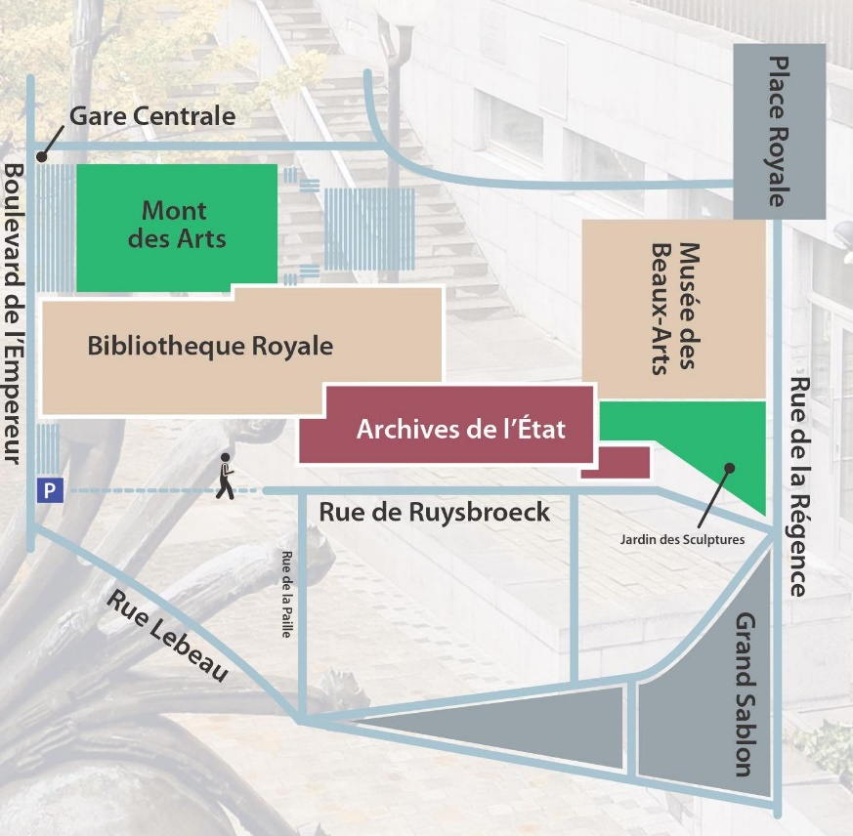
Venue
The Belgian State Archives have 20 repositories spread throughout the country. The DLM Forum Members' Meeting and Geoforum take place at the National Archives, the headquarters of the State Archives in Belgium. The National Archives holds the record collections of the Belgian central authorities and their legal predecessors.
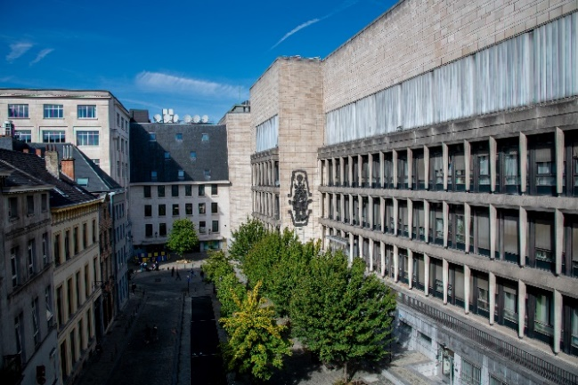

The address of the meetings is Rue de Ruysbroeck 8, 1000 Brussels (Google Maps).

The entrance for the meetings can be found at house number 8:

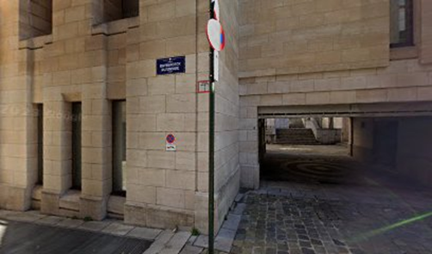

The dinner on the evening of the 27th of May will be held at Le Roy d'Espagne, Grand Place 1 (Google Maps).

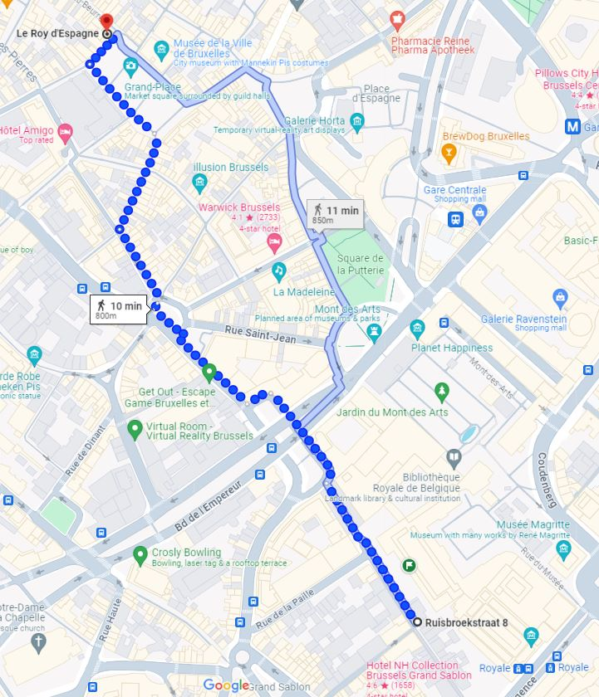

Getting there
The National Archives is located in the heart of Brussels, in the midst of the triangle Mont des Arts – Grand Sablon – Central Station.

- Nearest airport
  - Brussels airport
  - Direct train connects the airport to Brussels central station (about 15’)
- Arrival by international train
  - Thalys, Eurostar and ICE stop at Brussels-Midi station, from where, with your international ticket, you can change to a train to Brussels Central station (1 stop)
- Nearest railway station
  - Brussels Central station
  - Train timetables: www.nmbs.be
  - By foot, you can reach the National Archives from the Central station in more or less five minutes. Take the Boulevard de l’Empereur and walk down the stairs immediately after number 4 (the service entry of the Royal Library) to the Place de la Justice. There, an underpass leads directly to the Rue de Ruysbroeck, where the
National Archives are located on the left. The entrance for the meetings can be found at house number 8:
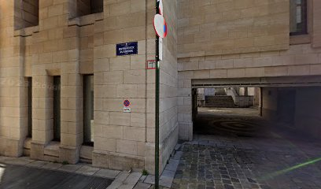
- Metro, tram and bus timetables
  - www.mivb.be
- Arrival by car
  - The National Archives do not have their own parking space. It is rather difficult to find a parking space in the vicinity, except in car parks with parking fees (e.g. Albertine-Square car park, entry at Place de la Justice 16).
Hotels
The choice of hotels in Brussels is vast. Most of them, however, are rather expensive – even more so in spring 2024. We selected some hotels, but there are many more.
- https://www.motel-one.com/en/hotels/brussels/hotel-brussels/
- https://craves-hotel.com/
- https://www.b-aparthotels.com/en/page/grand-place/b-aparthotel-brussels-grand-place-hotel-grand-place-brussels-official-website.2076.html
- https://www.florishotelarlequin.be/en/ (single rooms available)
- https://www.almahotel.be/nl/
- https://www.9-hotel-sablon-brussels.be/en/ (across the National Archives)
- https://www.9-hotel-central-brussels.be/en/ (single rooms available)
- https://all.accor.com/hotel/1046/index.en.shtml
- https://www.hotelhubert-brussels.be/ (single rooms available)
- https://www.ledixseptieme.be/
- https://www.arishotel.be
- https://www.atlas-hotel.be/
- https://www.dansaerthotel.com/en/
- https://www.nh-hotels.com/en/hotel/nh-brussels-carrefour-de-l-europe (single rooms available)
- https://www.hotelbedford.be/en/
For some hotels there are interesting offers through booking.com, while in other cases the best price is offered by the hotel itself.
There are also more alternative and or small-scale lodgings, such as:
- https://exclusivebrussels.be/exclusiveplaces/logement-bruxelles/ (website only in French, sorry)
- https://www.lamaisonhaute.be/
- https://www.discoverasr.com/en/citadines/belgium/citadines-toison-dor-brussels
- https://www.vintagehotel.be/en/
It may prove rewarding to look on the airbnb website, although the offer is not as great as in other large cities.

